
Project Name: Property Management System
Client Name: Noida Authority
Institutional Department

North Shore Technologies Pvt. Ltd.
_____________________________________________________________________________________________________

Logix Techno Park ♦ Sector 127 ♦ Noida – 201301 ♦ India
Phone : (120) – 404 3401
Contents

Introduction 4
Purpose & Objectives 4
User & Roles 5
Institutional – Complete Process 6
1. Allotment Process 7
1.1 Manage Scheme 8
1.2 Manage Notification 8
1.3 Manage Application Process 8
1.4 Manage Selection Process 8
1.5 Allotment & Payment 9
1.6 Business Rules for Allotment 9
2. Lease Deed Execution Request 12
2.1 Manage Lease Deed execution 13
2.2 Business Rules for Lease Deed 13
3. Possession Certificate Request 14
3.1 Possession Order Request 15
3.2 Possession Request Approval 15
3.3 Business Rules for Possession 15
4. Completion Certificate Request 17
4.1 Completion Certificate Request 18
4.2 Completion Request Approval 18
4.3 Business Rules for Completion Certificate 18
5. Functional Letter Request 19
5.1 Functional Letter Request 19
5.2 Functional Letter Approval 20
5.3 Functional Letter Issuance 20
5.4 Business Rule for Functional 20
6. Request for Transfer of Property 21
6.1 Manage Transfer Request 21
6.2 Transfer Approval 21
6.3 Manage Transfer Charges 22
6.4 Transfer Deed Execution 22
6.5 Business Rule for Transfer of Property 22
7. Mutation (Substitution) Request 24
7.1 Mutation Request 24
7.2 Mutation Approval 24
7.3 Business Rules for Mutation 25
8. Mortgage Request 26
8.1 Manage Mortgage Request 26
8.2 Mortgage Approval 27
8.3 Mortgage Letter Issuance 27
8.4 Business Rules for Mortgage 27
9. Change in Constitution Request 28
9.1 Manage CIC Request 29
9.2 CIC Approval 29
9.3 CIC Letter Issuance 29
9.4 Business Rules 29
10. Sublease Request 31
10.1. Manage Sublease Deed Execution 31
10.2 Business Rules for Sub-Lease Deed 32
11. Rent Permission Request 33
11.1 Manage Rent Permission Request 33
11.2 Rent Permission Request Approval 33
11.3 Business Rules for Renting 34
12. Miscellaneous Business Rules 35
12.1 Surrender 35
12.2 Restoration of Institutional Plot 35
12.3 Conversion 35
Annexure A 36
1. Allotment Letter 36
2. Payment Schedule (Demand Letter) 37
3. Rent Permission Letter 41
4. Transfer Memorandum 42
5. Mortgage Letter 43
6. Functional Certificate 44
7. Change in Constitution (CIC) Letter 45
8. Possession Letter 46

Introduction

NOIDA Constituted under the U.P. Industrial Area Development Act, 1976, has now emerged as a planned, integrated, modern Industrial City, well connect to Delhi through a network of roads, national highways and the ultra - modern DND flyover, offering inter - road linkages to all parts of the country. The growth rate of Noida has been remarkable since its inception, creating a need for an optimized business process to serve the citizens, and different establishments like industrial, commercial, institutional etc. In current working system within NOIDA, data management is primarily in physical form. A complete lack of interfaces at authority level to communicate makes it harder to conduct activities. An optimized business process is required across the different entities/departments of NOIDA to attain the desired level of efficacy and ensure better services to the citizens/consumers.
North Shore Technologies is developing an Integrated Property Management System that will allow automation of whole business process starting from allocation of institutional property to Lease deed execution; from Lease Deed to functional and various other processes including Transfers, Mortgage, and Substitution etc. This system would allow common work processes to be performed efficiently by all departments in NOIDA.

Purpose & Objectives

The overall purpose of this project is to build up an Integrated Property Management system. This system would allow automation of whole business process starting from allocation of institutional property to Lease deed execution; from Lease Deed to functional and various other processes including Transfers, Mortgage, and Substitution etc. This system would further facilitates access on web browser and allow adoption of a comprehensive approach towards gaining the efficiency. It would share the relevant information across various departments which will help in making operational as well as strategical decisions.
The key features of the system includes the automation of the business process involved right from allocation to the lease rent calculation and payment. The list of functional requirement for managing the institutional properties at NOIDA are as follow:
- Ability to add or upload list of allotted of Properties.
- Ability to manage the customer data.
- Ability to create payment schedule.
- Ability to calculate the payment at any point of time.
- Ability to auto generate various type of letter like allotment, possession, functional letter etc.
- Ability to send auto reminder to customer for any outstanding payment.
- Ability to see list of all relevant documents.
- Ability to connect with payment and receipt system for reconciliation at the end of every period.
- Ability to change the basic details of applicant.
- Ability to send an instruction to accounting system for payment or initiating the refunds.
- Ability to add any details to the properties.
- Ability to see various reports based on defined parameters.
- Ability to send notifications to customers using SMS/email.
- Ability to provide an interface which can be accessed by authorized Noida official anywhere and anytime.

User & Roles
The functioning of the department is classified on the basis of the below specified roles under the institutional department:
- Desk Officer/Department Head
This is a key role whose prime responsibility is to look after each and every business process within a department. This user would review the allottee’s requests and give his approval/rejection as per the guidelines/rules laid by the authority.

- Department Assistant
This user is involved in processing property requests received from the allottee. This user would feed allottee’s requests and other related details into the system. This user would also forward allottee’s request to the department head for his review.

- Allottee (Property Owner)
This user is involved in each activity of the property process model and is responsible for submitting the requests along with required documents to the department assistant.

Institutional – Complete Process

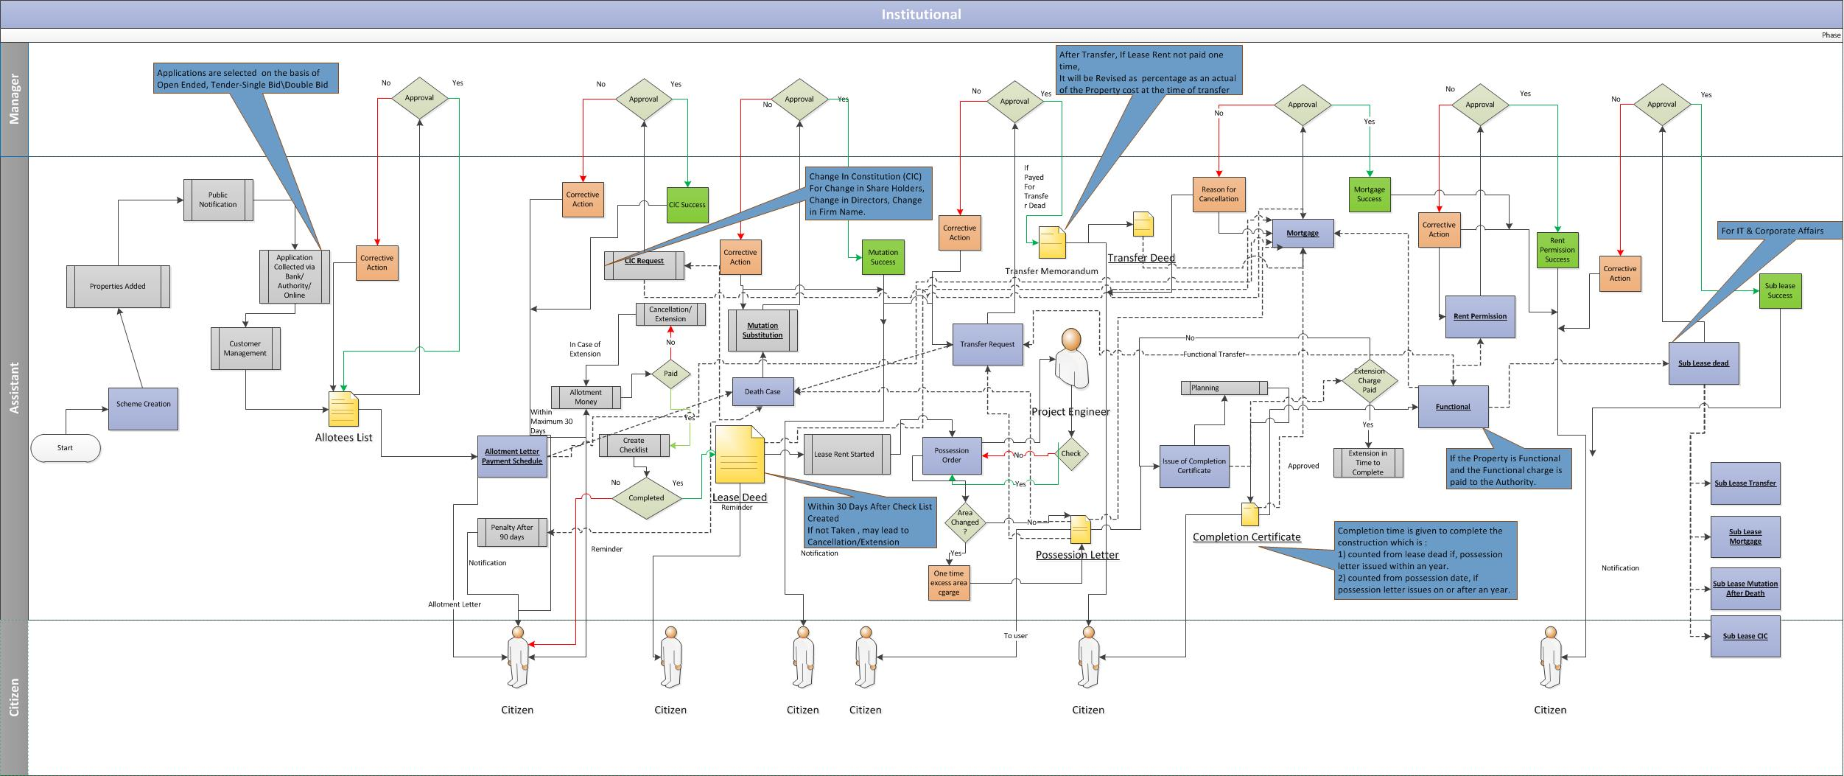

Allotment Process
The allotment process involves the allotment of the respective institutional property under a particular scheme to the successful applicant or allottee. The allotment can be done by various processes such as Draw-based, Open-Ended etc. The system also has provisions to accommodate other processes, such as Tender-based, for the allotment of institutional properties in future.
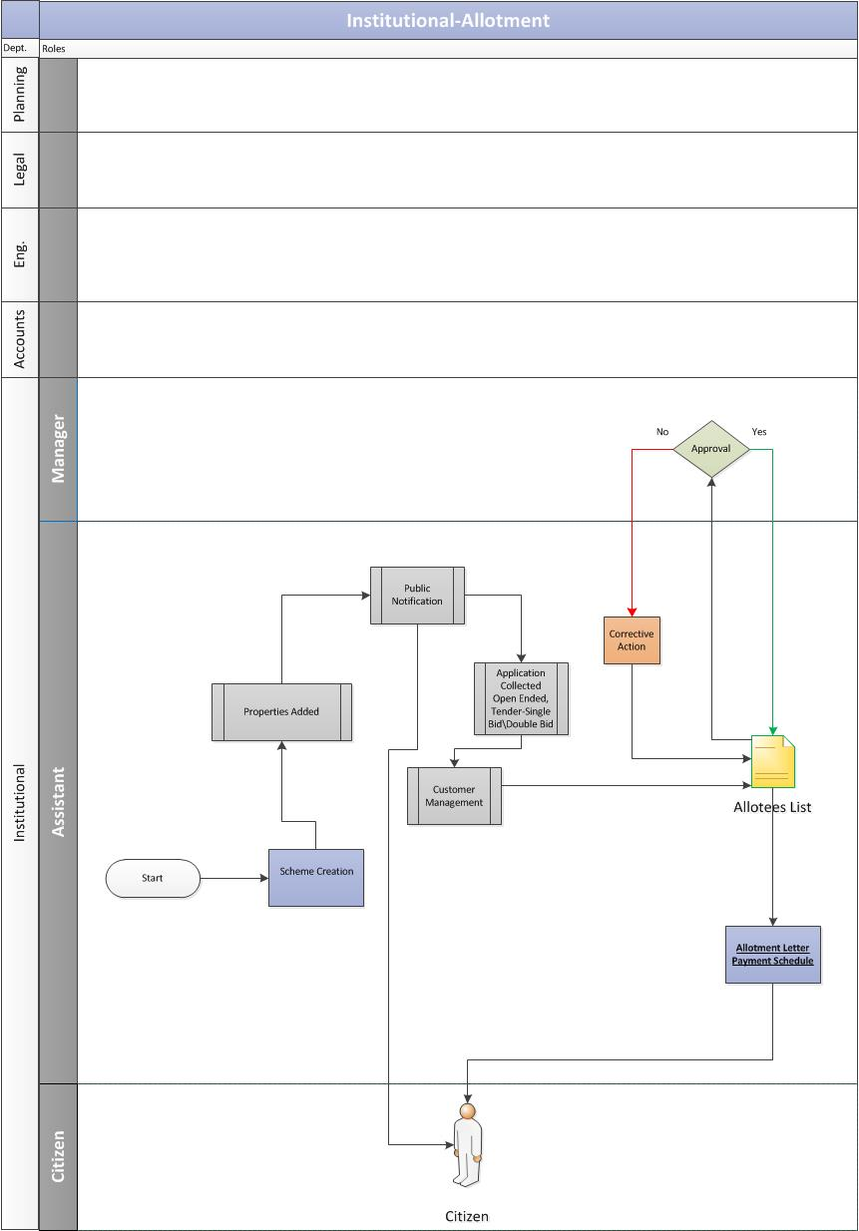

Manage Scheme
A scheme consist of set of properties that need to be allocated for various reasons. New system will have interface to manage schemes. Key functionalities of this process are as follow:
    - Add/Edit/Delete a Scheme
    - Activate/Deactivate a scheme
    - View list of Schemes.
    - Add properties to scheme
    - Bulk upload the property data to scheme
    - Detach property from a scheme
    - View list of properties in a scheme.
    - View list of properties in a scheme
    - Add-change the selection method
    - Add/Edit the interest rate for Premium/Installment, Lease rent, Penalty interest for defaulters.
    - Create rate card for properties
    - Calculate application fee for properties[Refer section 1.6 for calculation logic]

Manage Notification
This public notification contains the detailed information about the respective institutional scheme, the attached properties and the respective payment schedule and timelines. Key functionality of this process:
    - Add notification
    - Edit notification
    - Delete notifications
    - Activate/Deactivate Notifications
    - Attach/Detach scheme to the notification
    - List of notifications
    - Report to see the number of applicant against a notification

Manage Application Process
The application process would take place in three ways:
    - The allottee would submit the application form along with the processing fee directly to the authority.
    - The allottee would submit the application to the bank. The bank would then share the application forms and related details with the authority.
    - This process will also accommodate the future provision of online application for customers.
The key functionalities of this process are as follow:
    - Upload Applicant data received from bank.
    - Add applicant data.
    - Add payment information which will trigger the payment received as account receivable in Payment & Receipt system.
    - Search and list applicant based on various search parameter like name, mobile number.
    - Download list of applicants.

Manage Selection Process
There are various selection methods available like Draw, Open Ended, Tender etc. Each scheme has a defined selection process and the selection process will be managed separately. Key functionalities required to manage the selection process are as follow:
- Master data: Add/Edit/Delete/List selection method
- Add the member of selection board for each method
- Assign selection method to a scheme for institutional properties.
- Add/Edit/Delete the selection parameters for a selection process.

Allotment & Payment
In proposed solution, the manual process of draw/tender or any other selection process will be considered. However, the input at various stage will be recorded for open ended schemes. The key functionalities of this process are as follow:
    - Provide an interface for members to record interview feedback data in system. [schemes which requires interview].
    - Keep the history of execution of selection process
    - View history of the activities happened for an application.
    - Bulk upload of approved allotment data and auto approval within the system.
    - List of all selected applicant and bulk approval by relevant authority.
    - Allotment of a single property
    - Create a payment schedule for allottee based on the rule mentioned in section 1.6.5
    - Auto generation of allotment letter for the customer. [refer Annexure A for format]
    - Auto generate the demand letter.[refer Annexure A for format]
    - Create a lease deed schedule for all allocated properties.
    - List & download all properties based on filter criteria for a scheme.
    - Interface to post payment schedule in accounting system.
    - Initiate refund for unsuccessful applicant and automatically create an instruction for bank for different applicants.
    - Cancel allotment and initiate refund for customers
    - Change area of properties which in turn auto calculate the total cost of properties.

Business Rules for Allotment

    - Post-Allotment
      - Once property is allocated to customer, system will auto generate a registration. This unique registration ID will be used as unique identification for properties.
      - System will calculate Earnest Money, allotment money.
      - System will create Payment Schedule
      - System will generate Allotment Letter.

    - Calculation for total property cost
Property Cost for a given scheme is calculated on the basis of total area and the rate of allotment for the area. Below is the relation to calculate the Property Cost.

Property Cost = (AR * Rate) + LC

Where,
AR = Total Area (Sq. Mt.)
Rate = Allotment rate (per square meter, vary as per schemes)
LC = Location Charges (vary as per schemes)

    - Calculation of Earnest Money
An earnest money deposit shows the seller that a buyer is serious about purchasing a property. When the transaction is finalized, the funds are put toward the buyer's down payment. Earnest money is calculated as per the relation below.

Earnest Money = (Property Cost * P)/100

Where,
P= Defined percentage of the Property Cost

    - Calculation for allotment money
Allotment money is calculated using below relation

Allotment Money = (Property Cost * Q)/100)

Where,
Q = Defined percentage of the Property Cost

Note: - Allotment Money includes Earnest money.

    - Create Payment Schedule[Refer scheme info for interest rate]
The calculation of the payment schedule for Residential would be done using Reducing Monthly Installments. The formula for the same is as follows:
Total Premium Balance Amount = Total Cost of property – (allotment money + earnest money)

Principal Amount= Total Premium Balance Amount/No. of Installments

First Installment Interest Calculation = [Total Premium Balance Amount * (Rate of Interest/Frequency)]/100

The first installment in reducing monthly installment method can be calculated as:

Premium Balance Amount = Premium Balance Amount - First Installment Principal Amount

From First Installment Interest onwards,
Second Installment Interest Calculation = [Balance Premium Amount *(Rate of interest/Frequency)]/100

Premium Balance Amount = Premium Balance Amount - Second Installment Principal Amount

Similarly,
Nth Installment Interest Calculation = [Balance Premium Amount *(Rate of Interest/Frequency)]/100

Premium Balance Amount = Premium Balance Amount - nth Installment Principal Amount

    - Calculate outstanding payment at any point of time against a payment schedule
Dues are calculated e.g., if an instalment is missed, it is marked as dues.
Penal interest is applicable on dues

In case customer pay partial amount before due date of next instalment then, reconciliation takes place and penal interest is applicable
- Till date on the amount dues.
- Up to the due date for next instalment, on dues remaining (dues minus partial payment)
In case customer pays amount on due date then reconciliation takes place on due date.

Penal Interest = P*(1+r/100) ^ n

Where,
P = Principal
r = rate of interest
n = frequency

Lease Deed Execution Request
Once the lease money is paid, lease deed is signed between the authority and allottee. Here the authority declares that he/she is the lawful owner of the certain property and that the said property has been leased to the allottee for a certain duration of time in consideration of certain amount of money under certain terms and conditions.
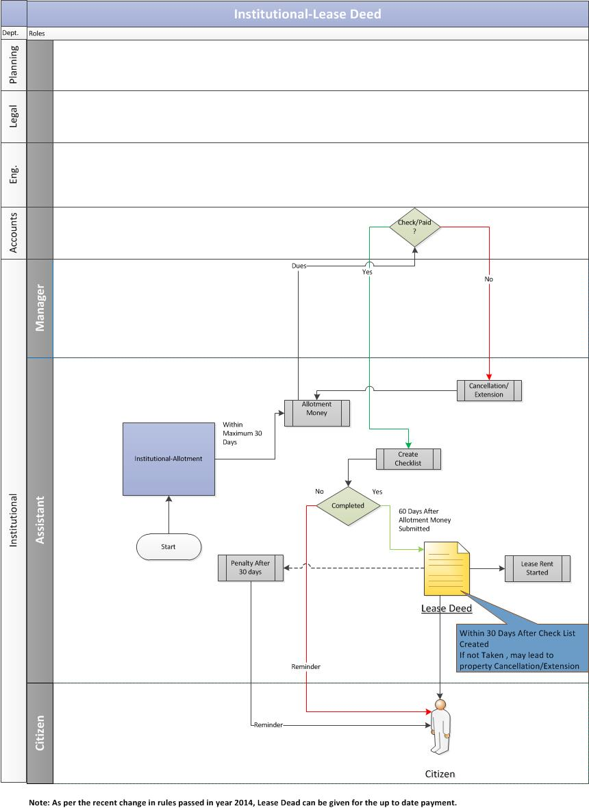

Manage Lease Deed execution

Post the allotment process, the allotment money needs to be paid by the allottee to the authority within a defined time-frame. Allotment money may vary as per the scheme and is calculated as a defined percentage of the total cost of the property. Below are the key functionalities of this process:

- Calculation of outstanding payment against the payment schedule for lease deed execution. [Refer sec 1.6.6]
- Calculation of penalty payment for delay in lease deed execution [Refer section 2.2]
- Make a payment for different account heads.
- Manage the terms and condition for lease deed execution
- Auto generation of list of documents or remaining documents expected from customer.
- Auto generation of letter for lease deed execution.
- Process Cancellation request and generate a cancellation letter.
- Add lease deed details to property
- List the properties which require lease deed execution based on filter criteria like scheme, sector etc.
- Calculation of one time lease rent. [Refer section 2.2]
- Calculation of annual lease rent at beginning of year and create a due payment.[Refer section 2.2]

Business Rules for Lease Deed
- After the successful completion of the lease deed, the lease rents starts which is revised to as per the rule as laid by the authority.
- Allottee is required to pay the lease money to the authority to enjoy the continued usage of the property for a defined time-frame. There are two options available to the allottee to pay the lease money.
    - In first option, the allottee can pay the lease money every year. In this instance, lease money is defined percentage of property size multiplied by the current circle rate.
    - In the second option, the allottee can pay lease rent of current year and multiply it with a certain number of years (as decided by the authority from time to time) and that would be considered as ONE TIME lease rent, which is equivalent to lease rent for entire lease duration of a defined time-frame.
PA=Property Area (Sq.mtr)
CR=Circle Rate
PER=Defined % by authority Rules
Per Year Lease Money= (PA*CR*PER)/100

One time Lease Money=Per Year Lease Money*Define Year by authority
- Lease Deed agreement is always on allotment rate.

Possession Certificate Request
Once the lease deed is executed, the allottee would submit the request for possession certificate to the authority. The authority would confirm the status of the property with the concerned engineering department. If the property is ready to be delivered then the authority would issue a possession certificate to the allottee.
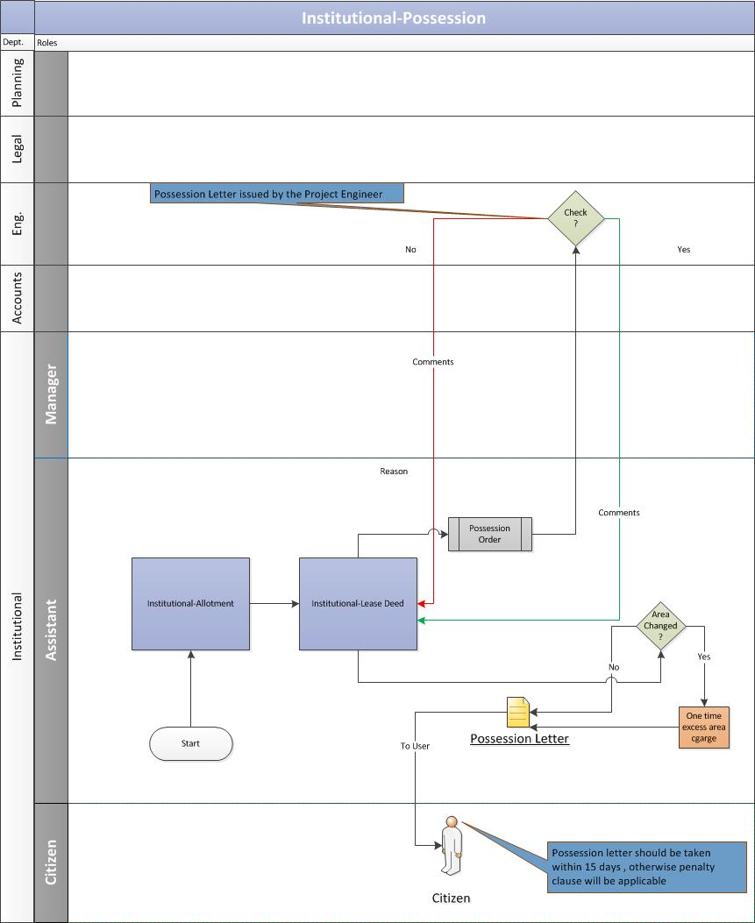

Possession Order Request
    - The Allottee duly submits the application along with the required documents to get the possession certificate for the property.
    - The system would auto-generate the Possession order which would then be send to the concerned engineering department for its approval.

Possession Request Approval
    - If the project engineer does not approve the possession order, then he/she is required to send the valid reason to the assistant. If the project engineer approves the possession order, the assistant will issue the possession letter to the Allottee. Key functionalities of this process are as follows:
      - Add/Update the status of the possession request
      - Auto-generation of the Possession letter

    - If there is a change in the property area during the possession phase, the assistant would readjust the area amount and would notify the same to the Allottee.
      - In case of increase in area, the assistant would calculate the excess amount and ask the Allottee to pay the same as a one-time payment. Once the Allottee pays the one-time excess amount, he will be issued the possession certificate.
      - In case of decrease in area, the assistant would then re-adjust the amount and reschedule the installments of the Allottee.
Key functionalities involved are:
  - System recalculates the cost based on the excess property area
  - System confirms the payment of full payment (with excess amount) with the account department.
  - System recreate the payment schedule (in case of decrease in area)
  - Auto-generation of Possession letter

Business Rules for Possession
- If there is a change in the property area during the possession phase, the assistant would readjust the area amount and would send the same to the Allottee.
- In case of increase in area, the assistant would calculate the excess amount and ask the Allottee to pay the same as a one-time payment. Once the Allottee pays the one-time excess amount, he will be issued the possession certificate.
- In case of decrease in area, the assistant would the re-adjust the amount and reschedule the installments of the Allottee.
- Excess area amount calculation = Excess Area * Allotment Rate (Units in per Sq. mtr)
- The possession letter should be requested by the Allottee within a stipulated time-frame from the time the possession order was approved. If he misses this time-frame, he would have to pay the penalty as decided by the authority.
- Once the possession letter is auto-generated by the system, various process would be initiated:
  - An email/sms notification would be send to the customer informing him to have his Building plan approved within a specific time-frame. The system would keep a track on the building plan approvals for all the properties.
  - Once the building plan is approved, the customer is informed via email/sms to have his completion certificate within a specific time-frame.
  - If the customer misses the timeline, he would be eligible for extension. In this case, the system would auto-generate a new payment order for the customer that would have the penalty, i.e. extension charges, added to the original amount.

Completion Certificate Request
The Completion certificate would be issued once the allottee shall complete the construction of building as per applicable Floor Area Ratio (FAR) and according to the Building Bye Laws of the Concerned Authority. This certificate would be issued by the authority within defined time from the due date of execution of lease deed. Completion certificate would ensure that there is a requisite infrastructure available with the allottee before he starts a unit.
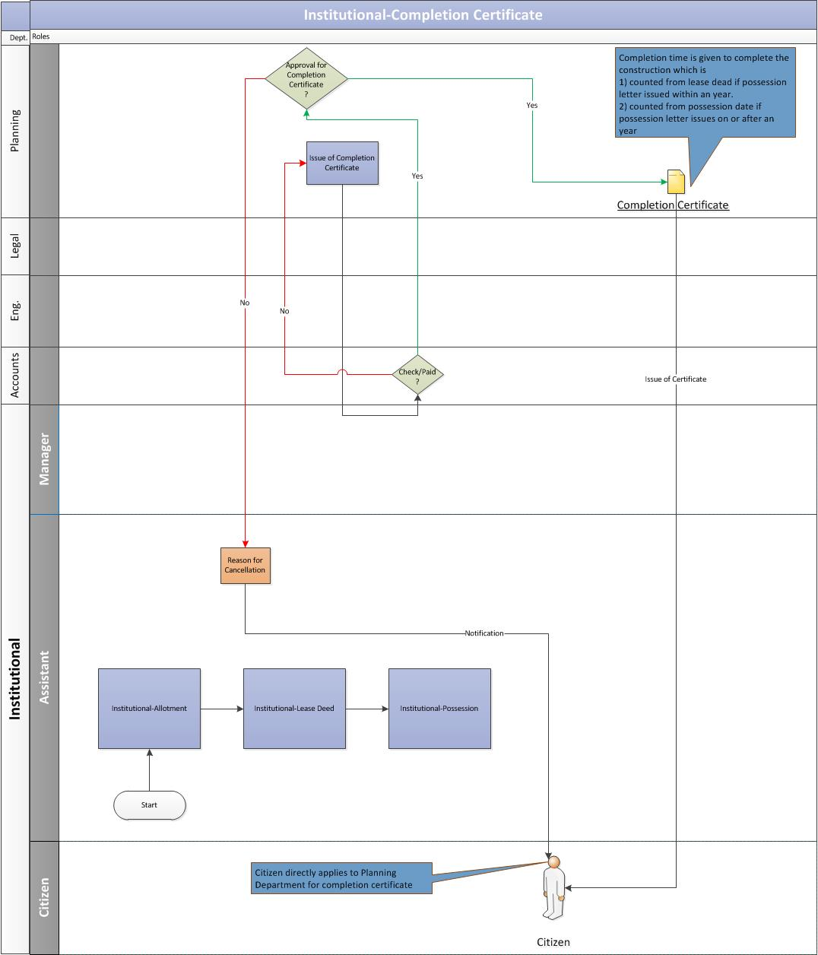

Completion Certificate Request
    - The allottee duly submits the completion certificate request along with the required documents to the concerned department at Noida Authority.

Completion Request Approval
    - The Planning department receives the completion certificate request and would validate the allottee’s documents.
    - The planning department verifies with the accounts department whether the Allottee has paid for the completion charges:
      - If the completion charges are paid by the Allottee and the account department gives a go-ahead then the Planning department would issue the completion certificate to the Allottee.
      - If the completion charges are not paid by the Allottee then the Planning department would not issue the completion certificate to the Allottee.

Key functionalities involved are:
- Add/Update the status for Completion Certificate request
- System confirms the payment of processing fee with the account department.

Business Rules for Completion Certificate
- It is mandatory to get the completion certificate issued after lease deed is executed for property within a stipulated time-frame.
- If the allottee apply for the completion certificate after the defined time-frame then appropriate upto date extension charges will be applicable.
- In case, allottee fails to complete the construction/part construction and commence the activity for which the land has been allotted, within the time period, or extended time period for the purpose, the allotment/ lease would be cancelled/ determined. On such cancellation/determination, a defined percentage of the premium or any other rate, as may be decided by the Authority from time to time, will be forfeited and the lessor shall resume possession of the plot.
- Once the completion certificate is issued by the planning department and the same had been updated in the system, various process would be initiated:
  - An email/sms notification would be send to the customer informing him to have his Functional letter within a specific time-frame.
  - If the customer misses the timeline, he would be eligible for extension. In this case, the system would auto-generate a new payment order for the customer that would have the penalty, i.e. extension charges, added to the original amount.

Functional Letter Request
“Functional Certificate” means the certificate issued by the Concerned Authority declaring unit is functional. The functional certificate would be issued from the Authority within a defined time-frame from the due date of issue of completion certificate.
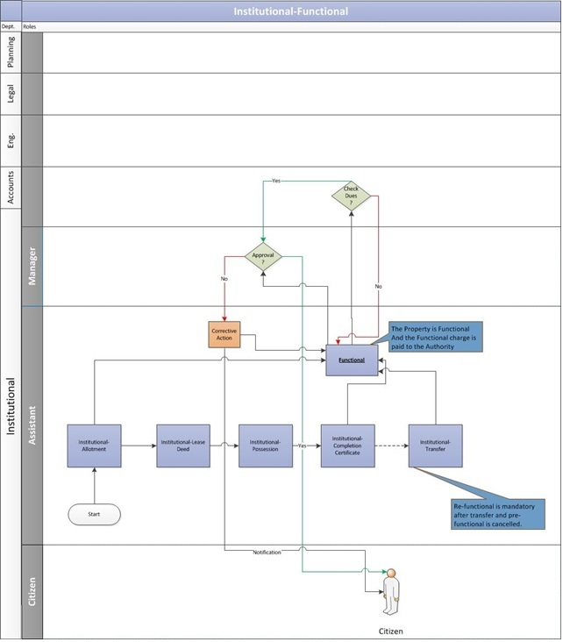

Functional Letter Request
    - The allottee duly submits the Functional letter request along with the required documents to the concerned department at Noida Authority.

Functional Letter Approval
    - The assistant would send the functional request to concerned engineering department to validate the property’s functional status.
    - The engineering department would survey the property to check if it’s functional or not. If it is functional then the engineering department would notify the assistant who in-turn will update the system.
    - Then assistant would send the same request to account department to validate the allottee’s account details for any pending dues.
    - The account department would verify the allottee’s account details. In case of no pending dues, the account department would issue a No Dues certificate.
    - After receiving the confirmation from concerned departments, the assistant would send the Functional request to the manager for his approval.

Key functionalities involved:
    - Add/Update functional request status
    - Record the details of the functional property.
    - System confirms the payment of processing fee and dues with the account department.
    - Email notification would be sent to the assistant once the Functional Letter request is approved.

Functional Letter Issuance
    - Once the manager approves the functional request, the assistant would issue the Functional letter to the Allottee.
Key functionalities involved:
- Auto-generation of the Functional Letter.

    - In case any previous dues exists, the system would notify the allottee via an email to clear the previous dues first before applying for the functional letter.

Business Rule for Functional
- An institutional unit, on submission of the following documents, may be declared functional:
  - Building completion certificate showing the maximum permissible covered area has been constructed.
  - Lease Deed/Transfer Deed/Sale Deed has been executed and registered.
  - No dues certificate has been issued by the authority.

Request for Transfer of Property
Transfer Memorandum is a permission granted by the authority to the seller of the property allowing to transfer his property rights to the buyer.

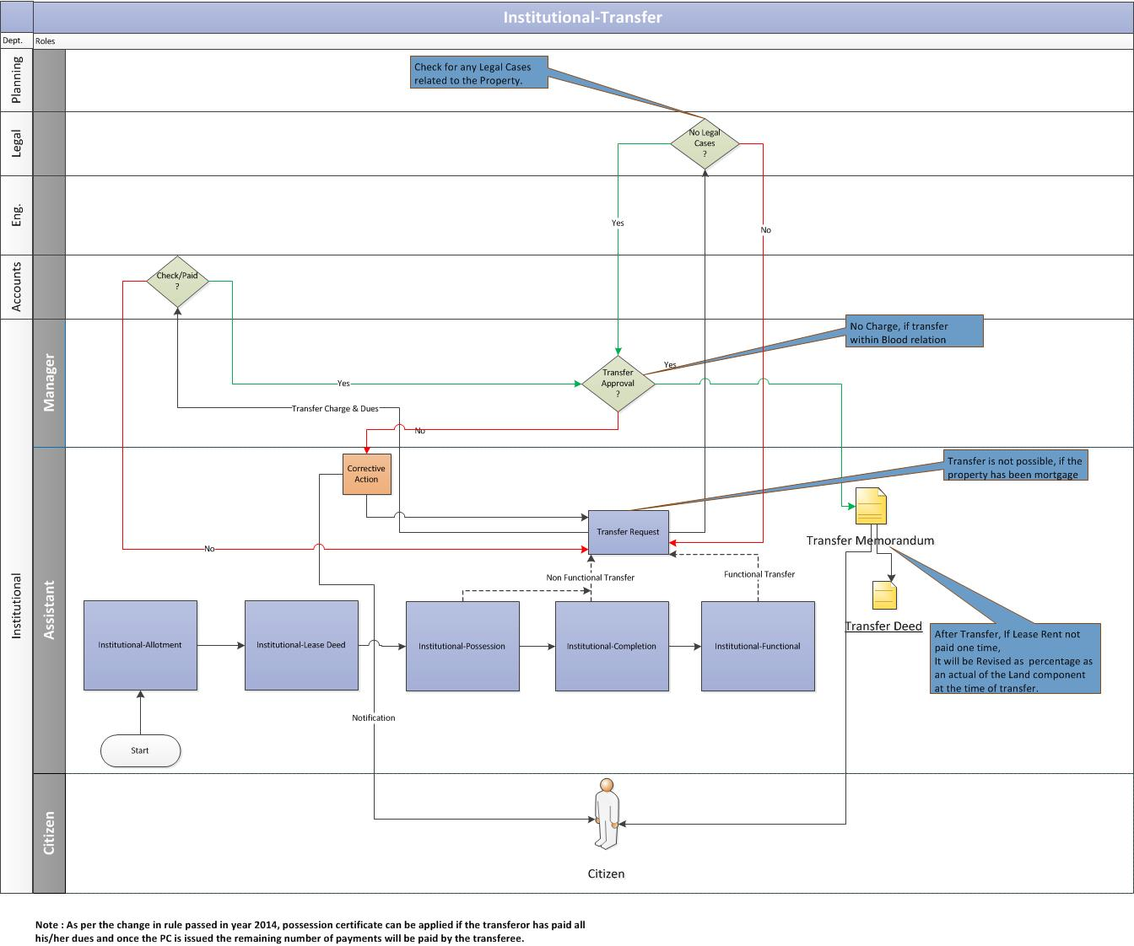

Manage Transfer Request
    - The transferor (allottee) of the property submits the transfer application request to the respective department at the Noida Authority. Key functionalities involved:
      - Add transfer request

Transfer Approval
    - Assistant would receive the transfer request and validate the allottee’s account details and litigation details with the concerned departments.
    - The account department would verify the allottee’s account details. In case of no pending dues, the account department would issue a No Dues certificate.
    - The legal department would verify if there are any legal cases on the property. In case of no legal cases, the legal department would issue a clearance certificate.
    - Post verification from the accounts and legal departments, the assistant would ask the Allottee to pay the transfer charges.

Key functionalities involved:

- Add/Update transfer request status

Manage Transfer Charges
    - The Allottee pays the transfer charges and updates the same to the authority.
    - The assistant verifies the transfer payment details with the account department.
    - After receiving the payment confirmation from accounts, the assistant would send the transfer request to the manager for his approval.
    - Once the manager approves the transfer request, the assistant would issue the Transfer memorandum to the Allottee.

Key functionalities involved:
- Add/Update transfer request status

Transfer Deed Execution
    - Based on the transfer memorandum, the transfer deed will be executed.
    - Auto-generation of Transfer Memorandum.

Business Rule for Transfer of Property
- When an allottee/lessee i.e. Individual Person (Proprietorship Firm) / Partnership firm/Pvt. Ltd. Co./Ltd. Co. wants to sell/transfer a unit located on an allotted plot to any another Individual Person (Proprietorship Firm) / Partnership firm/Pvt. Ltd. Co./Ltd. Co., it may be permitted as below:-
    - Transfer of functional & non-functional units shall be permitted.
    - The cases where cancellation has been effected are not eligible for transfer.
    - More than one institutional Property(s) allotted as one allotment can also be transferred individually to different transferee (s).
- Transfer charges are a defined percentage of the current allotment premium of the plot for functional units.
Transfer Charges for functional = (Area * Reserve Price)*Defined Percentage

Reserve Price = Circle Rate
Defined Percentage = Percentage set by the authority
Note: All the units are in per Sq. mtr

- In case of non-functional unit, transfer charges are a defined percentage of the current allotment premium of the plot & time extension charges upto the date of submission of transfer application are not payable.
Transfer Charges for non-functional = (Area * Reserve Price)*Defined Percentage

Reserve Price = Circle Rate
Defined Percentage = Percentage set by the authority
Note: All the units are in per Sq. mtr

- Once transfer is approved and Transfer Memorandum is issued and transfer deed is executed, all the assets and or liabilities against the institutional unit would pass on to the transferee.
- Lease rent will be charged at a defined percentage of the prevailing allotment premium with location charges, on the date of issue of transfer deed.
- The lessee/transferee shall execute a Transfer deed, after paying the necessary transfer charges, within a defined time from the date of issue of the Transfer Memorandum and a certified copy of the same shall be submitted to the authority. In case of default, appropriate penalty would be levied.
- In case of mutual transfer between transferor and transferee, the transferee would make the unit functional within a defined time-frame from the date of issue of Transfer Memorandum. However, the facility of extension for making the unit functional would be available to the transferee on payment of prescribed extension charges after expiry of one year.
- Transfer through a registered General Power of Attorney (GPA)
- Transfer within the blood relations of the registered General Power of Attorney (GPA) holder would be allowed on a stipulated payment amount of the normal transfer charges. Other than blood relatives of the registered GPA holder, the transfer charges shall be stipulated payment amount of the normal transfer charges.
- To initiate a transfer request, the transferor would pay the processing fee to the authority. This processing fee is a defined amount set by the authority.

Mutation (Substitution) Request
Mutation of property involves the change of title ownership of the property from the seller to the buyer when it is sold or transferred.
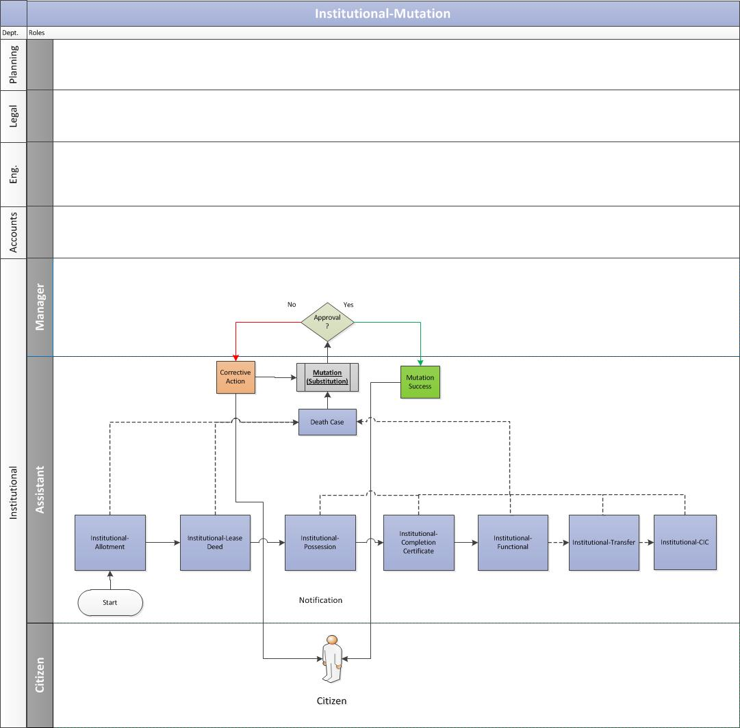

Mutation Request
    - If the owner of the property dies then the transferee/beneficiary of the property submit the application along with required documents at the housing department of the authority. Key Process includes:
- Add/Edit Mutation Request

Mutation Approval
    - The assistant receives the mutation (substitution) request and validate the application and documents attached to it.
    - If the papers are in place, the assistant would send the mutation request to the manager for his approval:
      - If the manager approves the mutation request, the assistant would issue the mutation letter to the Allottee.
      - If the manager rejects the request, an email notification would be sent to the assistant. The assistant would then share the same with the Allottee.

Key functionalities involved:
      - Add/Update the Mutation request status
      - Auto-generation of Mutation letter
      - System would record the details of the deceased member
      - System would also record the details of the new member on whose name the mutation is done.

Business Rules for Mutation
- Mutation after transfer of property is valid and possible.
- Mutation after transfer is always chargeable however in case of death it is not chargeable.

Mortgage Request
The allottee would request for the mortgage permission from the authority either before the lease deed execution or after the lease deed execution.
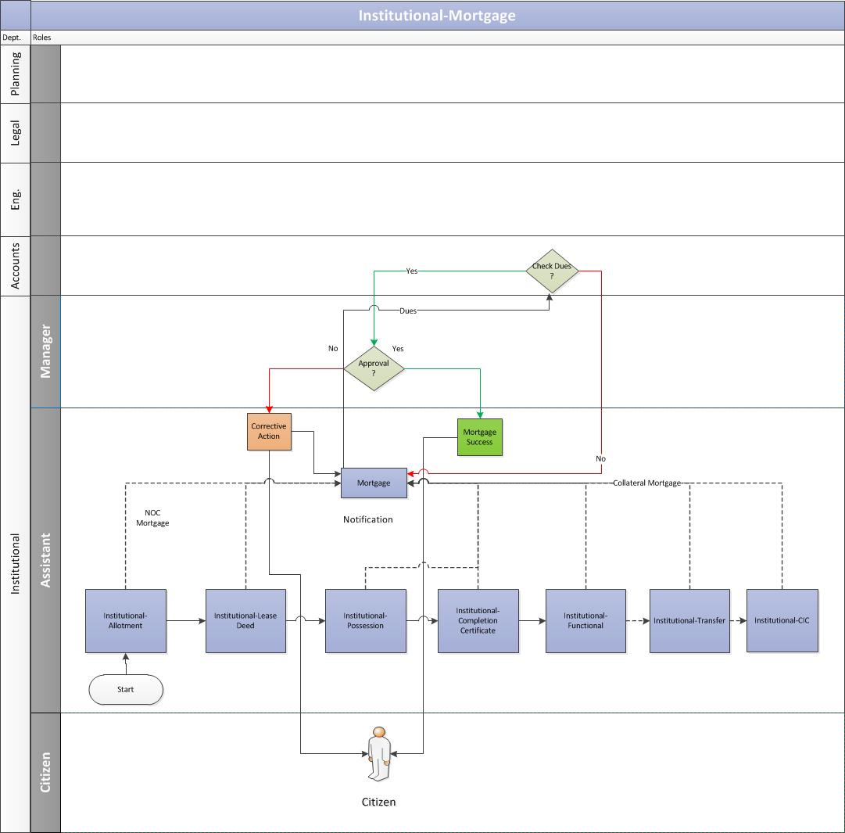

Manage Mortgage Request
    - The allottee duly submits the mortgage request along with the required documents, for the construction or re-construction on the plot allotted, to the concerned department at Noida Authority. Key functionality:
      - Add Mortgage request
      - Cancel Mortgage Request

Mortgage Approval
    - The assistant receives the mortgage request and would send the same to account department to validate the allottee’s account details for any pending dues.
      - The account department would verify the allottee’s account details. In case of no pending dues, the account department would issue a No Dues certificate.
      - After receiving the confirmation from accounts, the assistant would send the mortgage request to the manager for his approval.

Mortgage Letter Issuance
    - Once the manager approves the mortgage request, the assistant would issue the Mortgage letter to the Allottee.
    - In case any previous mortgage exists, the assistant would notify the Allottee to clear the previous dues first before applying for fresh mortgage.

Key functionalities involved:
      - Auto-generation of Mortgage letter
      - Dues/No Dues status would be updated on the system.
      - Email/sms notification to allottee to clear the previous dues first before applying for fresh mortgage.

Business Rules for Mortgage
- Mortgage is permitted where property is live and time limit for construction exists. No prior mortgage permission is required in cases where full premium alongwith interest and one time lease rent has been paid.
- Permission for collateral security would only be granted in cases where the unit has already been declared functional by the Authority. For the purpose of granting collateral security, processing fee would be charged as per the rule. Processing charges are
- Mortgage is permitted for financing the project on the institutional premises proposed for mortgage.

Request for Change in Constitution (CIC/CIS/CIN/COD)
The allottee would request for Change in Constitution letter in following situations:
- The Place of business may change
- The Partners may decide to change the name of the Firm
- There may be admission of new partners in the Firm
- The old partners may resign or leave from the Firm
- There may be change in the name and permanent address of the partners
- The minor Partner entered at time of constitution of firm may get the majority etc.
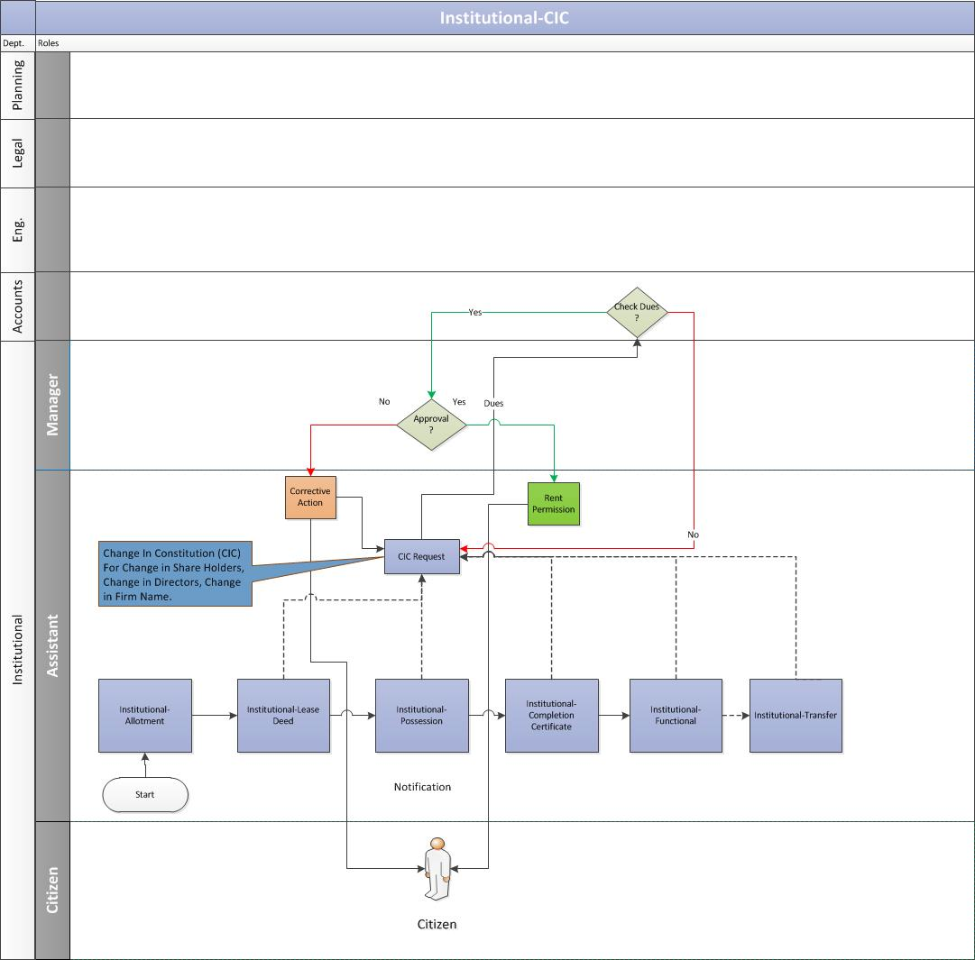

Manage CIC Request
    - The allottee duly submits the application along with CIC charges with required documents to the authority. Key functionality involved:
- Add CIC Request into the system.

CIC Approval
    - The assistant receives the CIC request and would send the same to account department to validate the allottee’s account details for any pending dues.
      - The account department would verify the allottee’s account details. In case of no pending dues, the account department would issue a No Dues certificate.
      - In case any previous dues exists, the assistant would notify the Allottee to clear the previous dues first before applying for the CIC letter.
    - Post verification from the accounts departments and if no dues exists, the assistant would ask the Allottee to pay the CIC charges.
    - The Allottee pays the CIC charges and updates the same to the authority.
    - The assistant verifies the CIC payment details with the accounts department.
    - After receiving the payment confirmation from accounts, the assistant would send the CIC request to the manager for his approval.

CIC Letter Issuance
    - Once the manager approves the CIC request, the assistant would issue the CIC letter to the Allottee.

Key functionalities involved:
      - Auto-generation of CIC letter
      - Update Dues/No Dues status

Business Rules
Application of Firm/Company/ Society/ Trust as the case may be can be submitted by the allottee to the concerned office alongwith the following documents:-
  - No dues certificate regarding upto date payment of dues from concerned Accounts Officer.
  - No CIC charges shall be applicable if the incoming partner/shareholder is any of the following relationship of the original allottee(s):
Father, mother, grandparents, sister, brother, son, daughter, husband/wife, grandson/granddaughter, wife of son/son-in-law, husband of granddaughter, wife of grandson and vice-versa (applicable for institutional plot/premises).
  - The allottee shall be required to retain minimum percent shareholding in the changed constitution as per terms and conditions of allotment/ lease deed for a defined time-frame.
  - Change in constitution shall be permissible before or after execution of lease deed and subject to payment of CIC charges equivalent to transfer charges to the extent of percentage of shareholding transferred.
  - A CIC deed shall be required to be executed and registered with the authority with respect to the change in constitution, which also includes change in shareholding within a defined time-frame from date of grant of such permission. It shall be required to execute irrespective of the relationship of the incoming partner(s)/shareholder(s).
  - The lease rent payable would not be revised as a consequence of Change in Constitution.
  - After Change in Constitution, a Change in Constitution Deed would be executed between the former and later Firm/Company, to be followed by its registration with the authority.
  - In case the property is acquired by way of transfer, and/or Firm/Company is changed by way of Change in Constitution, they would be required to execute the Transfer Deed.
  - If the name of a firm/company changes with the original firm/company not remaining in existence and partners/shareholders of the firm/company remaining the same and shareholding of the respective partners/shareholders also remaining the same, no CIS charges will be leviable and only a declaratory agreement without registration would be executed and submitted to the authority.
  - If the name of a firm changes with original firm remaining in existence and partners of the firm also change, then CIS charges would be leviable and the allottee(s)/lessee(s)/transferee(s) would also have to execute the required legal documents with the authority.

Sublease Request
The allottee would request sublease permission from the authority to sale a part of his already leased property.
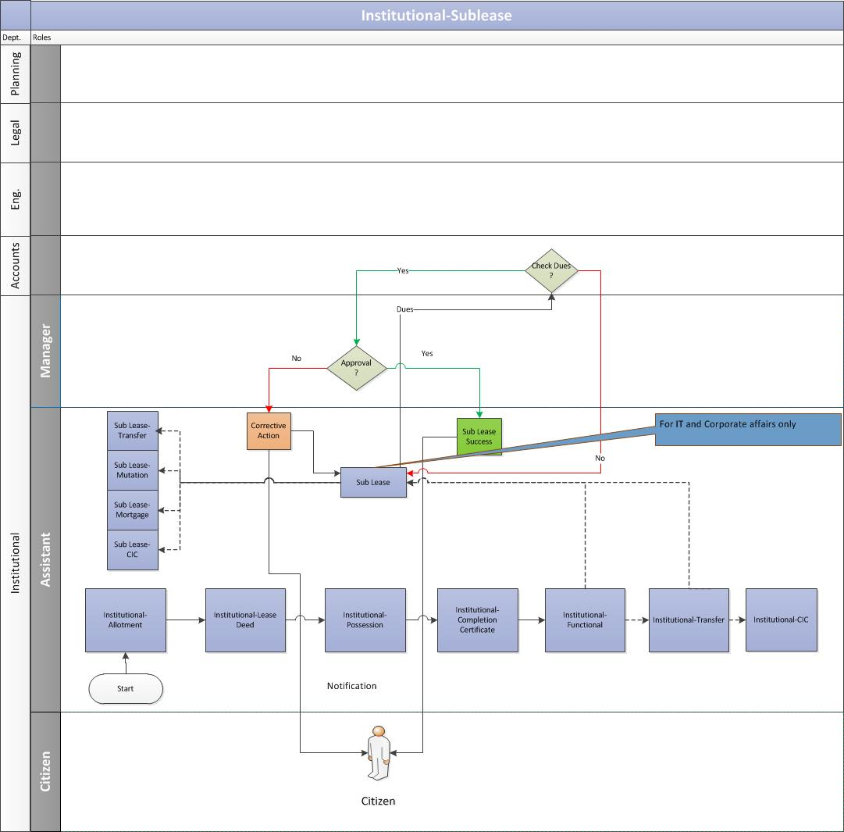

Manage Sublease Deed Execution
The allottee duly submits the application along with sublease charges with required documents to the authority. Below are the key functionalities of this process:
    - Calculation of outstanding payment against the payment schedule for lease deed execution. [Refer sec 1.6.6]
    - Manager the terms and condition for sub-lease deed execution.
    - Auto generation of list of documents or remaining documents expected from customer.
    - Auto generation of letter for sub-lease deed execution.
    - Add sub-lease deed details to property.

Business Rules for Sub-Lease Deed
- The allottee would only sub-lease the part of his property for which he has the respective completion certificate. For example, if the allottee has acquired the completion certificate for 70% of the total size of property then the allottee is allowed to sub-lease only a part of that 70% property and not all.
- The allottee would only sub-lease the property for IT or Corporates.

Rent Permission Request
An allottee would request for rent permission if he is looking to rent his/her property/part of property to a third party. Rent Permission charges as per the rules set by the respective authority.
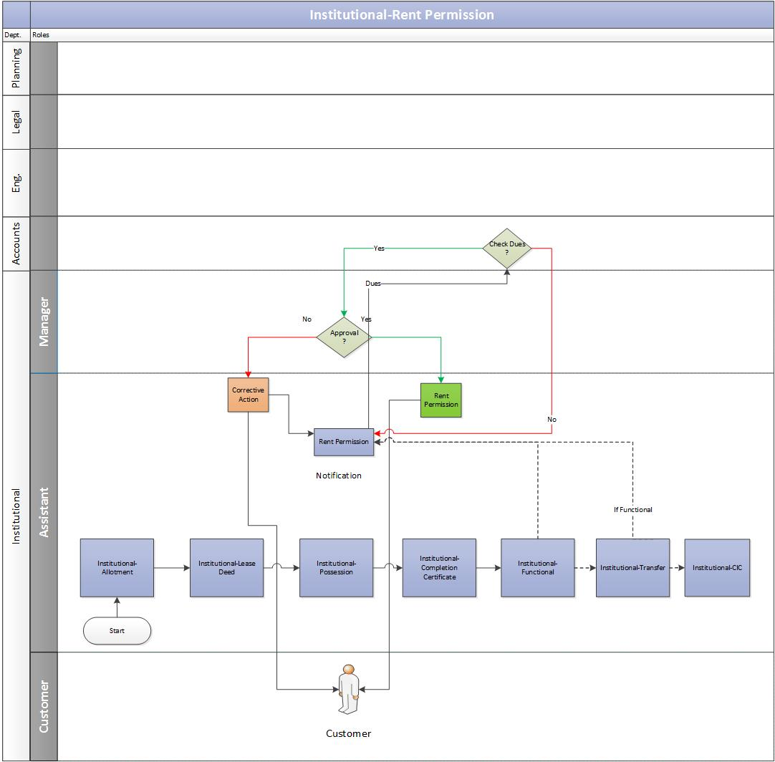

Manage Rent Permission Request
    - The allottee duly submits the application along with the rent permission charges with required documents to the authority.
    - The system would add the rent permission request.

Rent Permission Request Approval
    - The assistant receives the rent permission request and would send the same to account department to validate the allottee’s account details for any pending dues.
      - The account department would verify the allottee’s account details. In case of no pending dues, the account department would issue a No Dues certificate.
      - In case any previous dues exists, the assistant would notify the Allottee to clear the previous dues first before applying for the rent permission letter.
    - Post verification from the accounts departments and if no dues exists, the assistant would ask the Allottee to pay the rent permission charges.
    - The Allottee pays the rent permission charges and updates the same to the authority.
    - The assistant verifies the rent payment details with the accounts department.
    - After receiving the payment confirmation from accounts, the assistant would send the rent permission request to the manager for his approval.
    - Once the manager approves the request, the assistant would issue the rent permission letter to the Allottee.

Key functionalities involved:
      - Auto-generation of Rent Permission Letter
      - Update Dues/No Dues status

Business Rules for Renting

- The institutional premises for which renting permission is required should not be a cancelled one and should have been declared functional by the authority.

- Renting permission is granted if:

- Upto date dues of authority have been cleared.
- Lease deed/Transfer deed/Sale deed as applicable has been executed.
- NOC’s of the term lending Institution (s), in case the institutional premises is mortgaged/ offered as collateral security.

- In case of re-renting, the renting charges would be deposited again.
- If any tenant leaves tenancy before a defined term then for balance remaining period, permission can be granted for new tenant on payment of a percentage of prevailing rate of renting charges for the entire plot area and subject to fulfillment of other terms and conditions.
- Rent Permission charge = (FAR * Defined Amount) * N
FAR = Floor Area Ratio
Defined Amount = Area-wise amount set by the authority
N = number of years

Miscellaneous Business Rules

Surrender
  - The allottee has to execute surrender deed, if lease deed/transfer deed has been executed and all the original legal documents are to be surrendered unconditionally in Institutional Department of the Authority.

Restoration of Institutional Plot
The Authority can exercise cancellation of institutional plot/shed for breach of terms and conditions of allotment/lease deed/Transfer deed. However, the Chief Executive Officer/or any other officer authorized by him can restore the plot. The restoration will be subject to the following conditions:-
- The allottee would pay restoration charges at a defined percentage of the prevailing rate/ reserve price.
- The allottee has to produce NOC of accounts department.
- The allottee has to pay time extension charges as per terms of allotment/lease.
- Transfer and/or Change in Constitution of the unit would not be allowed outside the blood relations, till the unit is declared functional by the authority.

Conversion
  - The conversion will be subject to the following conditions:-
    - The allottee must have deposited the allotment money along with interest, if any
    - Converted plot is allotted at the land rate prevailing on the date of conversion letter plus conversion charges and location benefit charges as given below.

- Within the allotted institutional phase – a percentage of the land rate prevailing on the date of conversion letter.
- Outside the allotted institutional Phase – a percentage of the rate prevailing on the date of conversion letter.

    - The date of issue of conversion letter would be deemed as date of allotment for all practical purposes i.e. for execution of lease deed, possession, interest on balance amount etc.

Annexure A

Allotment Letter
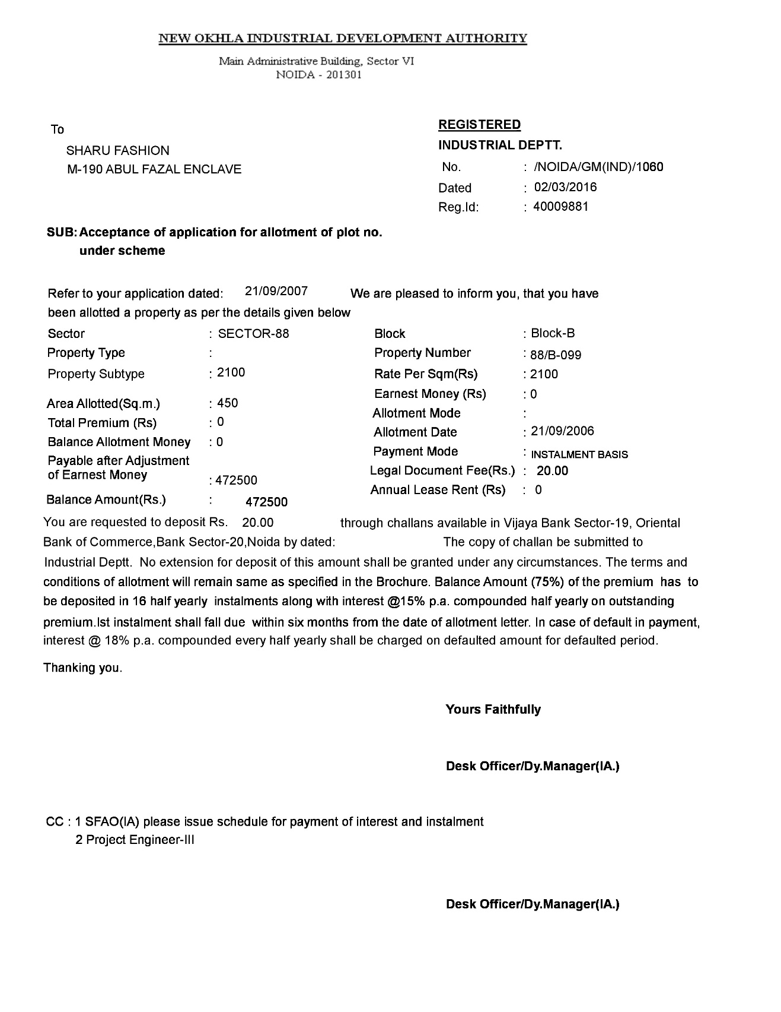

Payment Schedule (Demand Letter)

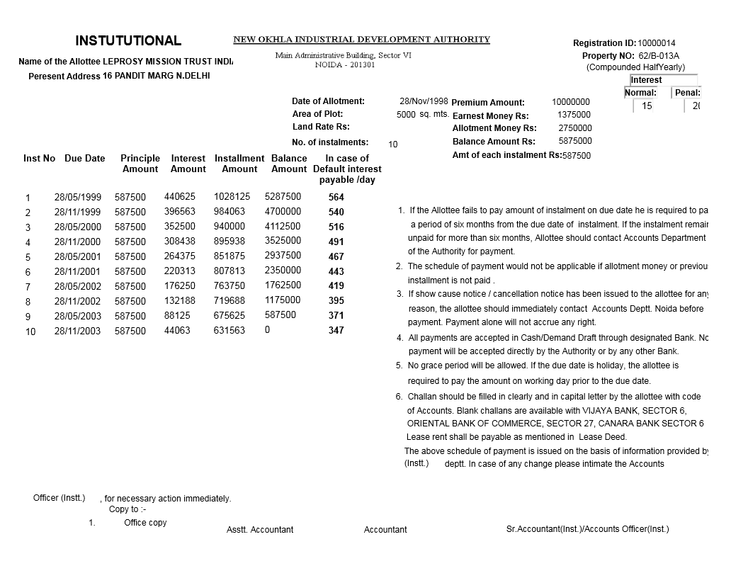

Payment Schedule Example

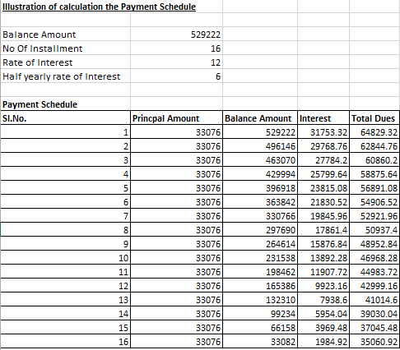

Dues Calculation Example
            - Part Payment Calculation

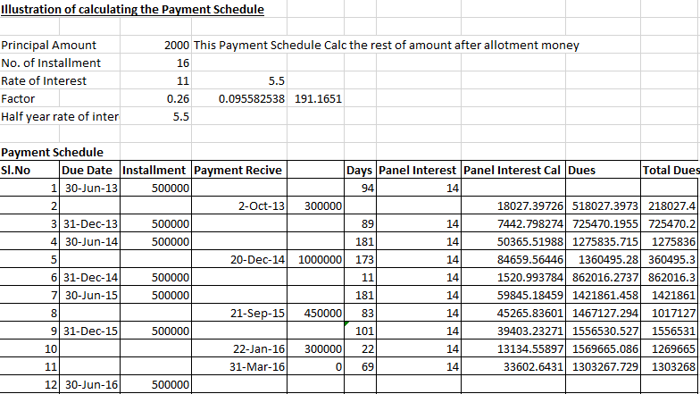

Example 2 – All Payments Outstanding Calculation

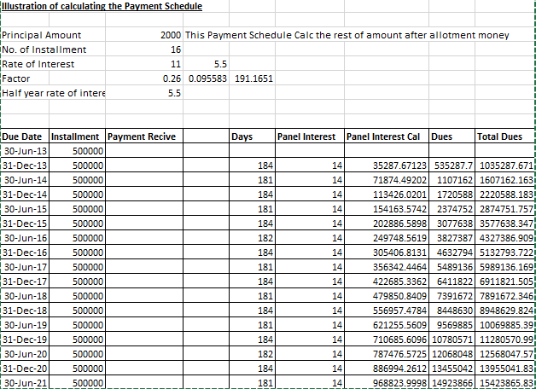

Note:
  - For the first six months (from 1st January to 30th June), the number of days for calculating the daily interest would be 181 days. In the case of leap year, the number of days for calculating the daily interest would be 182 days.

  - For the last six months (from 1st July to 31st December), the number of days for calculating the daily interest would be 183 days.

  - The panel interest will be applicable if the payments are defaulted.

  - If a person defaults, then penal interest would be applied to his outstanding payment. Penal interest can be calculated as

p*(1+r/100)^n

Where, P = Principal
r = rate of interest
n = frequency

Rent Permission Letter
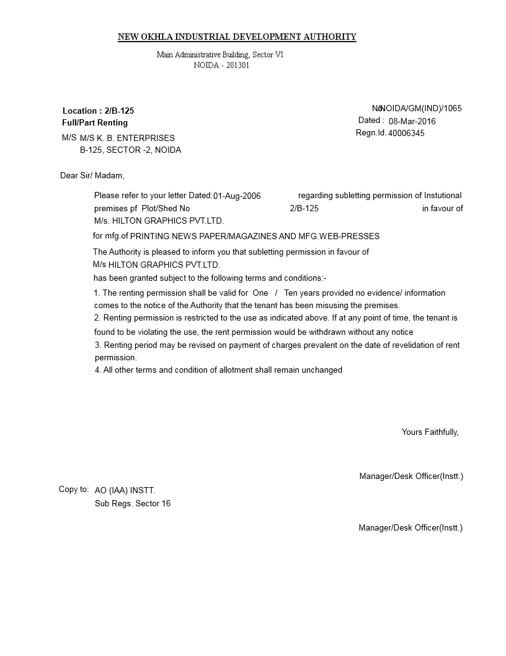

Transfer Memorandum

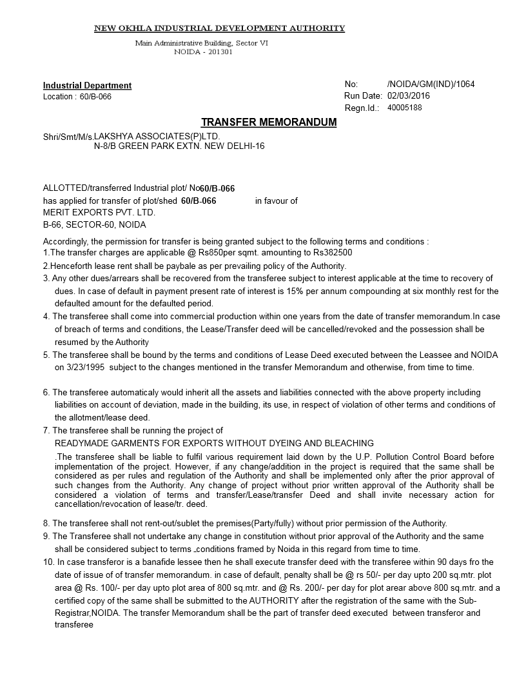

Mortgage Letter

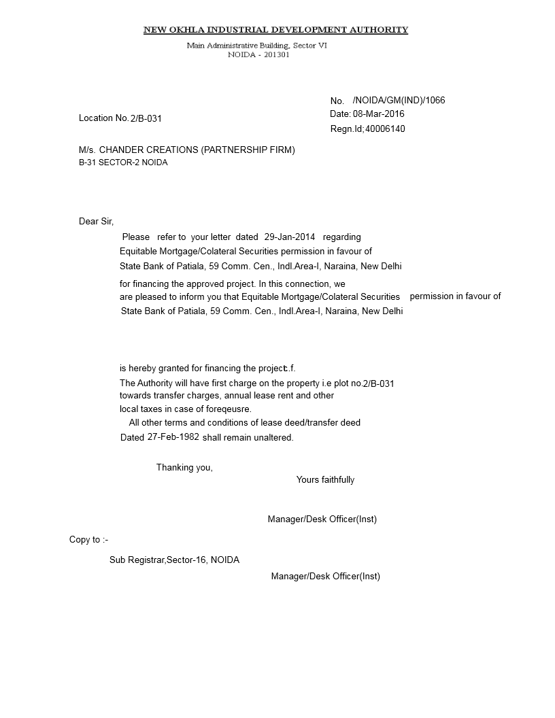

Functional Certificate

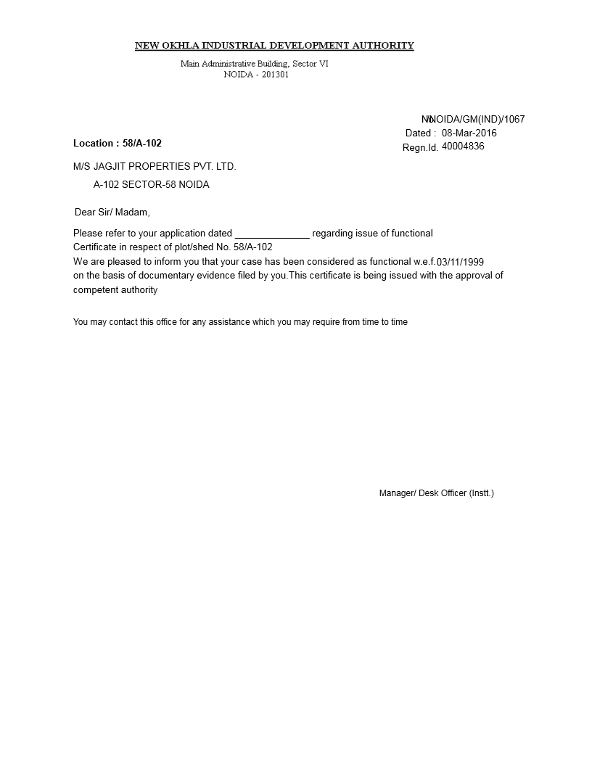

Change in Constitution (CIC) Letter

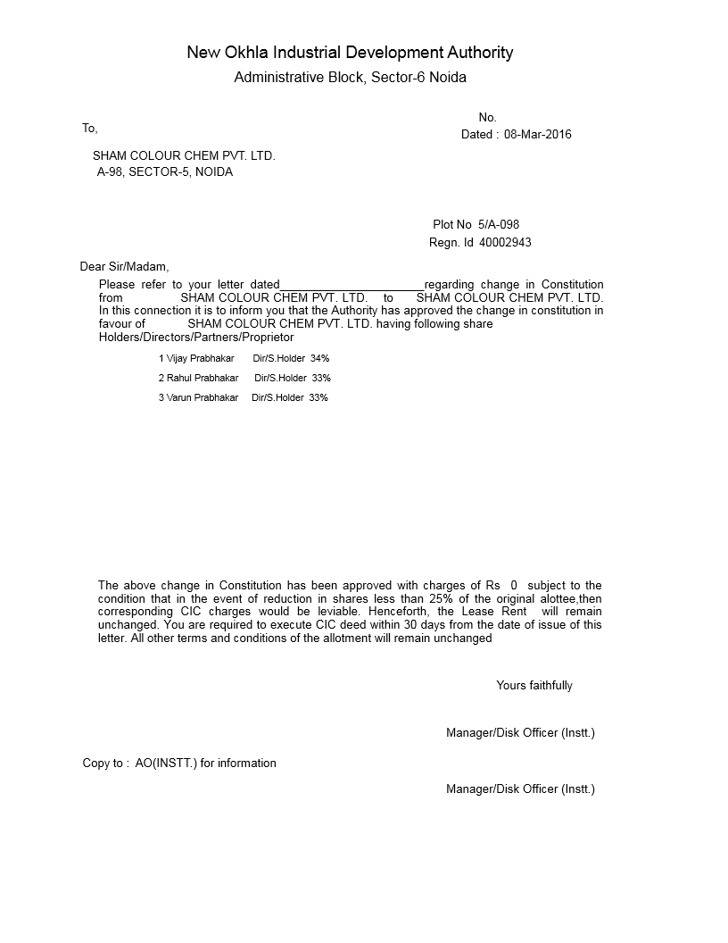

Possession Letter

